Prospective families and individuals who qualify as first-time and non-first-time homebuyers with incomes between 80.01 percent up to 120 percent of area median income (AMI), are eligible to apply and receive up to $15,000 in funding. Homebuyers must contribute a minimum of $1,000 of their own funds to put towards the purchase of their home with zero cash back at the closing table, and participate in a pre-purchase financial literacy counseling session.

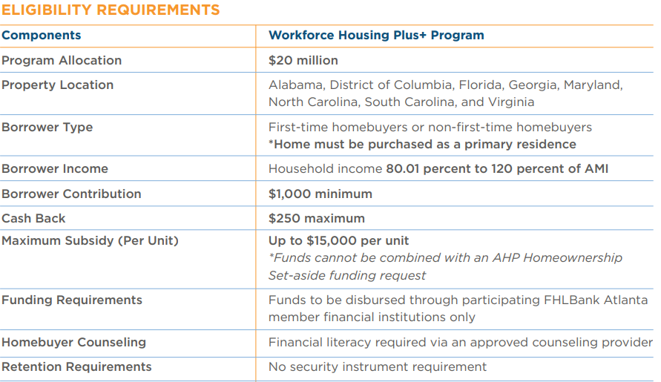



**Jacob Crowder**

Mortgage Banker  
803-719-1005  
[jcrowder@firstpalmetto.com](mailto:jcrowder@firstpalmetto.com)

*Workforce Plus is a product of the Federal Home Loan Bank of Atlanta. Household income restrictions and other requirements apply. Please see Federal Home Loan Bank of Atlanta’s Affordable Housing Program Implementation Plan at www.fhlbatl.com for complete product requirements