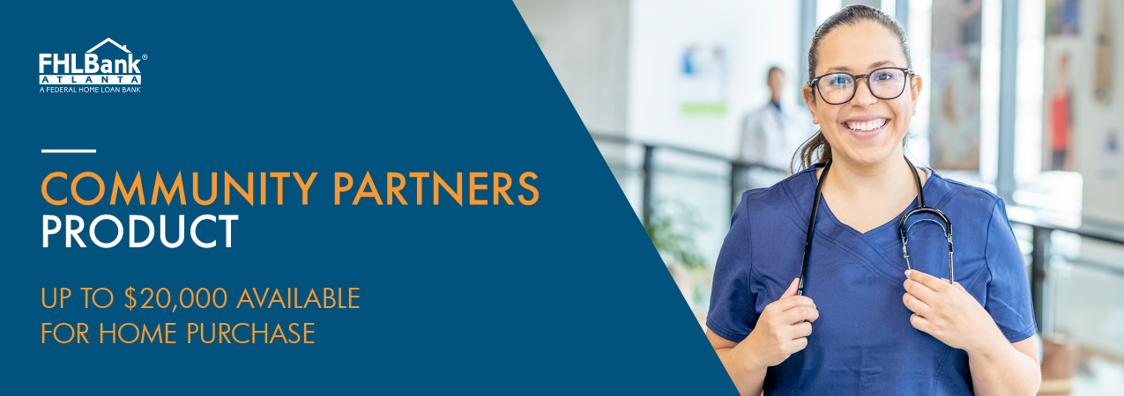At First Palmetto Bank, we are committed to supporting families and individuals who make their living serving others in the community. As part of this commitment, we offer a unique financial opportunity for current or retired law enforcement officers, educators, health care workers, firefighters, and other first responders; and veterans and active-duty members of the military or their surviving spouse who are purchasing a home.  
  
First Palmetto Bank can help homebuyers access up to $20,000 to assist with the down payment, closing costs, and rehabilitation costs incurred when purchasing a home.  
  
Funding is available to qualified homebuyers that meet product and income eligibility requirements, including first-time homebuyers or families and individuals that currently own a home or have previously owned a home.

In addition to meeting eligibility requirements, the homebuyer must:

* Contribute at least $1,000 toward the purchase of the home
* Occupy the home as a primary residence
* Complete a homebuyer education and financial literacy course specified by FHLBank Atlanta

**Please contact one of our loan officers to determine if you are eligible for Community Partners funding to begin your application process.**

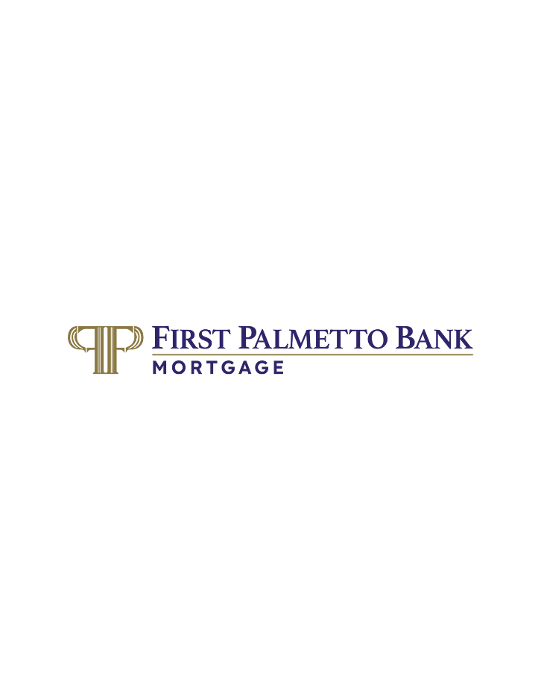  
  
**Jacob Crowder**Mortgage Bank  
803-719-1005  
[jcrowder@firstpalmetto.com](mailto:jcrowder@firstpalmetto.com)

*Community Partners is a product of the Federal Home Loan Bank of Atlanta. Household income restrictions and other requirements apply. Please see Federal Home Loan Bank of Atlanta’s Affordable Housing Program Implementation Plan at www.fhlbatl.com for complete product requirements.